* [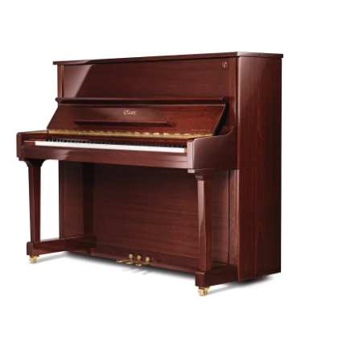](http://www.steinway.com/pianos/essex/upright/eup-123e)

[EUP-123E Classic Studio](http://www.steinway.com/pianos/essex/upright/eup-123e)

A nicely balanced upright with elegantly proportioned classic straight legs, the classic design of the EUP-123E, or Classic Studio Upright, makes a great choice for even the most eclectic of homes.

[READ MORE](http://www.steinway.com/pianos/essex/upright/eup-123e)

* [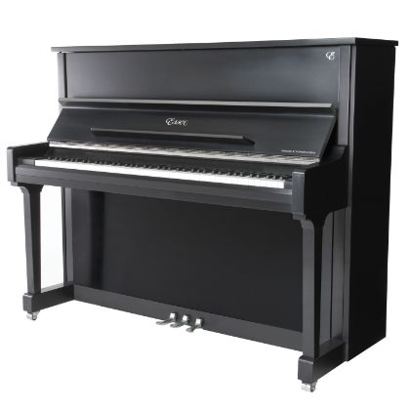](http://www.steinway.com/pianos/essex/upright/eup-123ek)

[EUP-123EK Classic Studio Brushed Nickel](http://www.steinway.com/pianos/essex/upright/eup-123ek)

A nicely balanced upright with elegantly proportioned classic straight legs, the classic design of the EUP-123EK, or Classic Studio Upright with brushed nickel hardware, makes a great choice for even the most eclectic of homes.

[READ MORE](http://www.steinway.com/pianos/essex/upright/eup-123ek)

* [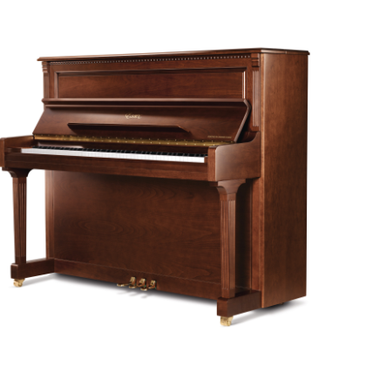](http://www.steinway.com/pianos/essex/upright/eup-123fl)

[EUP-123FL Empire Studio](http://www.steinway.com/pianos/essex/upright/eup-123fl)

A stately and majestic design, the Empire Studio Upright (EUP-123FL) projects a commanding presence and blends beautifully with nearly any décor.

[READ MORE](http://www.steinway.com/pianos/essex/upright/eup-123fl)

* [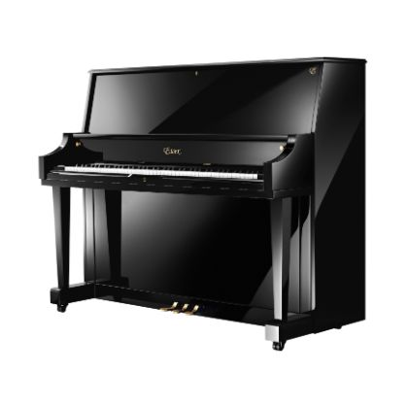](http://www.steinway.com/pianos/essex/upright/eup-123s)

[EUP-123S Institutional Studio](http://www.steinway.com/pianos/essex/upright/eup-123s)

The EUP-123S, our Institutional Studio Upright, is ideally equipped to provide great performance and durability in challenging school and institutional settings.

[READ MORE](http://www.steinway.com/pianos/essex/upright/eup-123s)

* [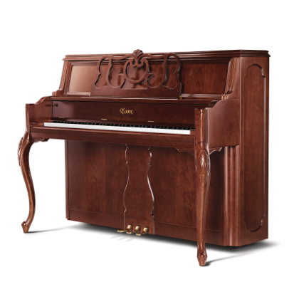](http://www.steinway.com/pianos/essex/upright/eup-116ff-open)

[EUP-116FF Formal French - Brown Cherry Satin](http://www.steinway.com/pianos/essex/upright/eup-116ff-open)

Grace and flair perfectly describe the Brown Cherry Satin-finished EUP-116FF BCHS. This Formal French design features an expressive open music rack with graceful curves and top center hand-carved ornamentation.

[READ MORE](http://www.steinway.com/pianos/essex/upright/eup-116ff-open)

* [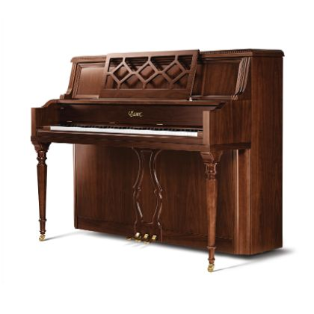](http://www.steinway.com/pianos/essex/upright/eup-116ec)

[EUP-116EC English Country](http://www.steinway.com/pianos/essex/upright/eup-116ec)

This finely crafted English Country Upright (EUP-116EC) is warm and appealing, reflecting a lustrous satin finish. The timeless, tasteful design, and effortless beauty is sure to intrigue the discriminating home decorator.

[READ MORE](http://www.steinway.com/pianos/essex/upright/eup-116ec)

* [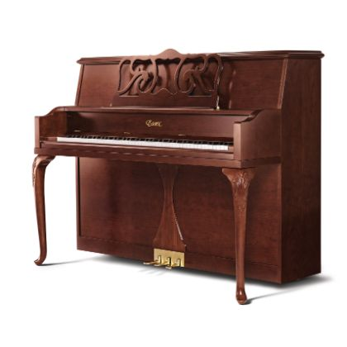](http://www.steinway.com/pianos/essex/upright/eup-116qa)

[EUP-116QA Queen Anne](http://www.steinway.com/pianos/essex/upright/eup-116qa)

The well-balanced proportion and graceful appearance of the Queen Anne Upright (EUP-116QA) brings style and refinement to any home. It is distinguished by exceptional craftsmanship, utilizing linear curvature design, soft outlines and simplicity. The beautiful hand-carved reliefs on the legs are also known as Acanthus leaf, symbolizing quality, longevity and creativity.

[READ MORE](http://www.steinway.com/pianos/essex/upright/eup-116qa)

* [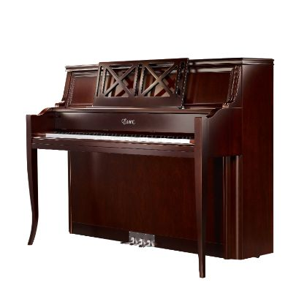](http://www.steinway.com/pianos/essex/upright/eup-116ct)

[EUP-116CT Contemporary](http://www.steinway.com/pianos/essex/upright/eup-116ct)

Form follows function in the sumptuous Contemporary Upright (EUP-116CT). A wonderful interpretation of the modern style, it features a deep eggplant / aubergine color, popular for today's furniture. This model is an ideal complement for many decorating styles.

[READ MORE](http://www.steinway.com/pianos/essex/upright/eup-116ct)

* [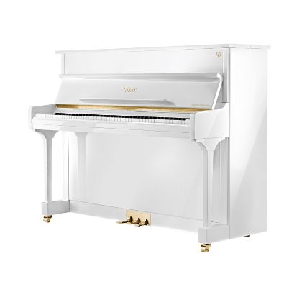](http://www.steinway.com/pianos/essex/upright/eup-116e)

[EUP-116E Classic Studio](http://www.steinway.com/pianos/essex/upright/eup-116e)

Available in White Polish, Ebony Polish, Sapele Mahagany Polish, and Walnut Polish, the Classic Studio Upright (EUP-116E) is the perfect choice for any home. With its classic design, it is sure to compliment any interior space.

[READ MORE](http://www.steinway.com/pianos/essex/upright/eup-116e)

* [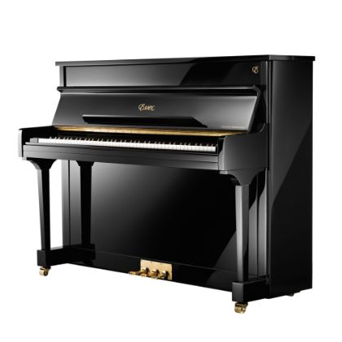](http://www.steinway.com/pianos/essex/upright/eup-111e)

[EUP-111E Classic Studio](http://www.steinway.com/pianos/essex/upright/eup-111e)

Available in White Polish, Ebony Polish, Sapele Mahagany Polish, and Walnut Polish, the Classic Studio Upright (EUP-111E) is the perfect choice for any home. With its classic design, it is sure to compliment any interior space.

[READ MORE](http://www.steinway.com/pianos/essex/upright/eup-111e)

* [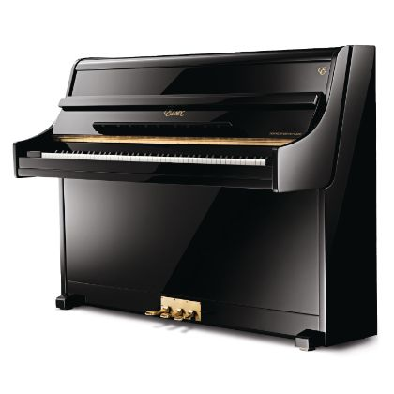](http://www.steinway.com/pianos/essex/upright/eup-108c)

[EUP-108C Classic Studio](http://www.steinway.com/pianos/essex/upright/eup-108c)

The styling of the Continental Upright (EUP-108C) puts it at home in any décor. The contemporary design offers distinctive and stylish elegance at an affordable price.

[READ MORE](http://www.steinway.com/pianos/essex/upright/eup-108c)